|  |  |  |  |
| --- | --- | --- | --- |
| logo ngan.png | | **MINISTRY OF EDUCATION AND TRAINING** | |
| **FPT UNIVERSITY** | |
| **CAPSTONE PROJECT DOCUMENT** | |
| **BUILDING A WEBSITE SUPPORT THE ACTIVITIES “TIẾP SỨC MÙA THI” CAMPAIGN**  **Project Report #1 – Project Introduction** | |
|  | |
| |  |  | | --- | --- | | **Group 22** | | | **Group Members** | |  |  | | --- | --- | | SE60769 | Nguyen Duy Khoa | | SE60687 | Le Nguyen Huu Tri | | 60358 | Nguyen Dinh Tuan | | 60325 | Tran Nguyen Kim Vinh | | 60339 | Nguyen Vinh Hien | | | **Supervisor** | Nguyen Trong Tai | | **Ext Supervisor** | N/A | | **Capstone Project Code** | TSMT Website | | |
| - Ho Chi Minh City, January 2014 - | |

TABLE OF CONTENTS

1 Introduction Software 3

1.1 Project Title 3

1.2 Overview of Existing Methods 3

1.3 Limitations of Existing Methods 3

1.4 Project Objective 3

1.5 Scope Definition 3

1.6 Approach 4

1.7 Guest Functions 4

1.8 Charities Functions 4

1.9 Manager Functions 4

1.10 Volunteers Functions 4

1.11 Candidates Functions 4

1.12 Admin Functions 5

1.13 Table Introduction 5

# Introduction Software

## Project Title

Building a website support the activities "Tiếp Sức Mùa Thi" campaign.

## Overview of Existing Methods

Nowadays, when the exam season for [universities](http://en.wikipedia.org/wiki/Universities) and [colleges](http://en.wikipedia.org/wiki/Colleges) come, a lot of charities, volunteers want to use their houses, lodges, motorbike, or even money to support the candidates, especially whose not have good conditions. The volunteers will help the candidates to find a lodge and suggest them some place for good meals, and the route to the schools, etc. By then, the charities will manage the entire processes.

In fact, the number of existence system which have some functions really helpful for all roles above is so tiny that can be counted on the fingers.

## Limitations of Existing Methods

* The majority of all activities are recorded on paper.
* Weak and unpopular: Existing methods just give an information about place, university, bus’s route and map.
* The charities only can charitable giving through newspaper, banners, etc…
* Therefore, it is very hard for candidates to find out where is the suitable place for them.

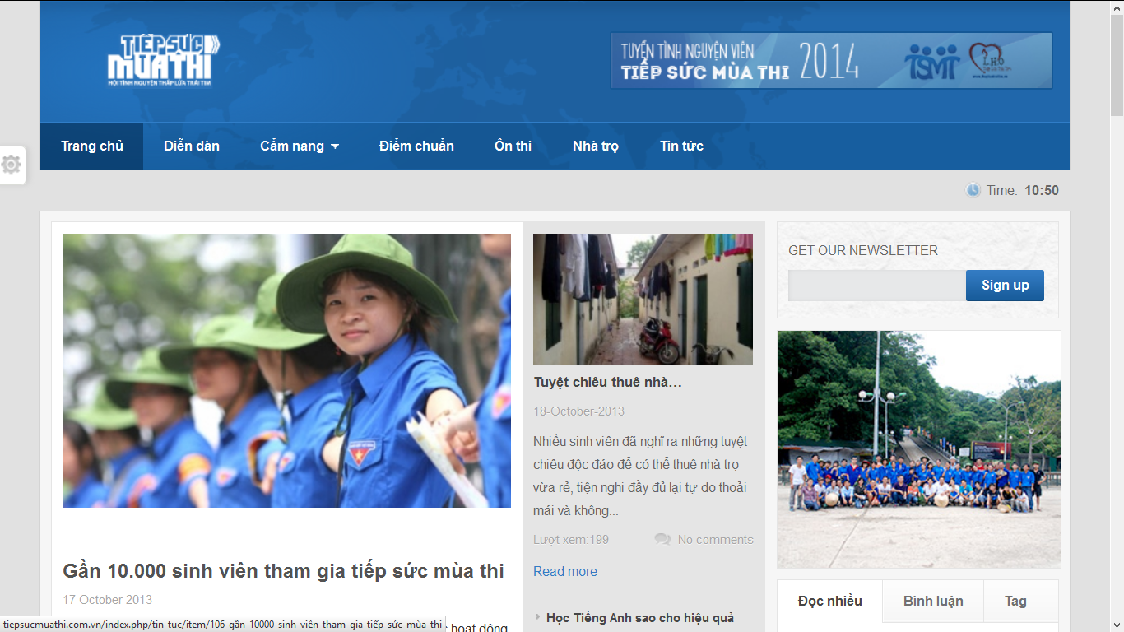

*Figure 1-1: Tiepsucmuathi.com basic interface*

For examples, from the website “Tiếp sức mùa thi” (tiepsucmuathi.com.vn), with good interface but functions of that website aren’t implemented.

## Project Objective

We will develop a website that will help:

* Volunteers, representatives and charities can register and submit their sponsor information.
* Candidates can register and post their information and lodging request.
* The system can suggest the planning for pick up the candidates.
* The system will automatically arrange lodging for candidates based on some criteria like gender, groups, personal requests, etc.
* The system can suggest the router on the map, as far as the best router that the cars should go, based on some criteria like shortest distances, shortest time required, etc.
* The system will automatically arrange seats for candidates based on some criteria like maximum slots, docking by groups, genders, etc.

## Scope Definition

* The main scope of our system is help the volunteers and charities can giving their help to the candidates, and the candidates can get suitable help more easily than the traditional way.
* Focus on main modules:
* User management.
* Optimize planning, scheduling, arrangement for candidates.
* Sponsor management.
* Rating and commenting.
* Searching, statistic.

## Approach

* Get comment of some real charities, volunteers and candidates.
* Use some current website to find out how it work.
* Brainstorm in our group.

## Guest Functions

* Register.
* View news, tips.
* Search resources.
* Search lodge information.
* View maps.
* View statistics.

## Charities Functions

* Manage resources.
* Manage account.
* Comment and rating.
* View request.

## Manager Functions

* Manage requests.
* Manage schedules.
* Manage accounts.
* Manage volunteers.
* Comment and rating posts.

## Volunteers Functions

* Manage account.
* View schedules.
* View maps.
* View requests.
* Manage news, tips.
* Comment and rating posts.

## Candidates Functions

* Search resources.
* Manage requests.
* Manage account.
* Comment and rating posts.

## Admin Functions

* View system statistics.
* Manager users.
* Manage news.
* Manage resources.
* Manage schedules.
* Manage comments.
* Comment and rating posts.

## Table Introduction

|  |  |  |  |  |  |
| --- | --- | --- | --- | --- | --- |
| **Roles and Responsibility:** | | | | | |
| **No** | **Full name** | | **Role** | **Position** | **Contact** |
| 1 | Nguyen Trong Tai | | Supervisor | Instructor | taint@fpt.edu.vn |
| 2 | Nguyen Duy Khoa | | Leader | Team leader | khoandse60769@fpt.edu.vn |
| 3 | Le Nguyen Huu Tri | | Developer | Team member | trilnhse60687@fpt.edu.vn |
| 4 | Nguyen Dinh Tuan | | Developer | Team member | tuannd60358@fpt.edu.vn |
| 5 | Tran Nguyen Kim Vinh | | Developer | Team member | vinhtnk60325@fpt.edu.vn |
| 6 | Nguyen Vinh Hien | | Developer | Team member | hiennv60339@fpt.edu.vn |
|  | | | | | |
| **Project Authorization:** | | | | | |
| **Approved by** | | | **Role** | | **Date** |
| Nguyen Trong Tai | | | Supervisor | | 06/01/2014 |
|  | | | | | |
| **Comments:** | | N/A | | | |